Feedback - Team 7

1. Add package description
2. public IllegalMoveException() Add what the default error message is.
3. Add a sample pom.xml file. Its super confusing otherwise.
4. The API is super super detailed and good. But I think it's overkill. Too many options, which is good, but maybe do we need so much? Ex: Custom grid dimensions
5. Although its a design decision, much of the code in the client can be abstracted out to put in the API itself, thereby making user experience simpler
6. While creating client i had to declare a lot of variables which i had no knowledge of, as the sample code could have been a more usable snippet.
7. References to private variable made in the sample code. I had to replace them to getters.
8. No mention of which Java version to use. Popular java versions (like 16) not supported. Since i did not have Java 17, I could not run the game. [Changing Java version would break a lot of other projects that are currently running on my system]

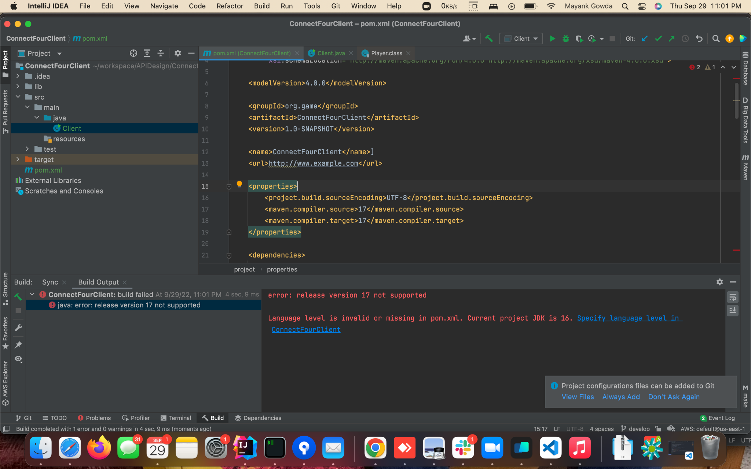

Getting an error while running client.

Apart from the minor issues listed above, the API is really well designed. Super impressed with the work done. Kudos to the team.